https://drought.emergency.copernicus.eu/data/factsheets/factsheet_spi.pdf
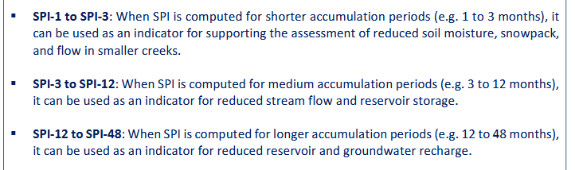
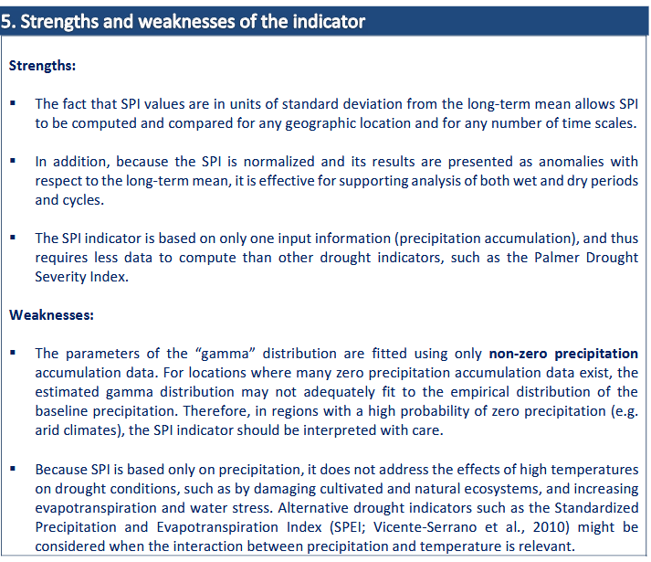
WMO SPI User Guide:
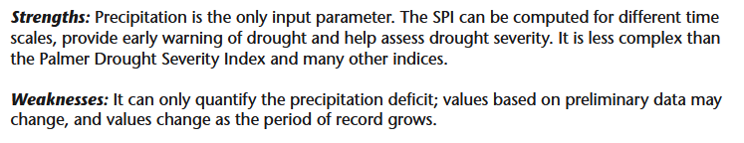
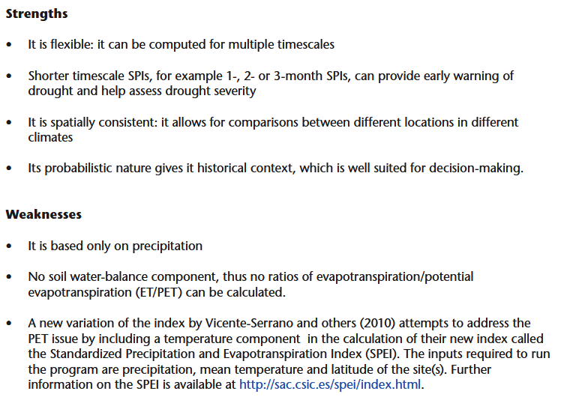
Major Limitation of our work
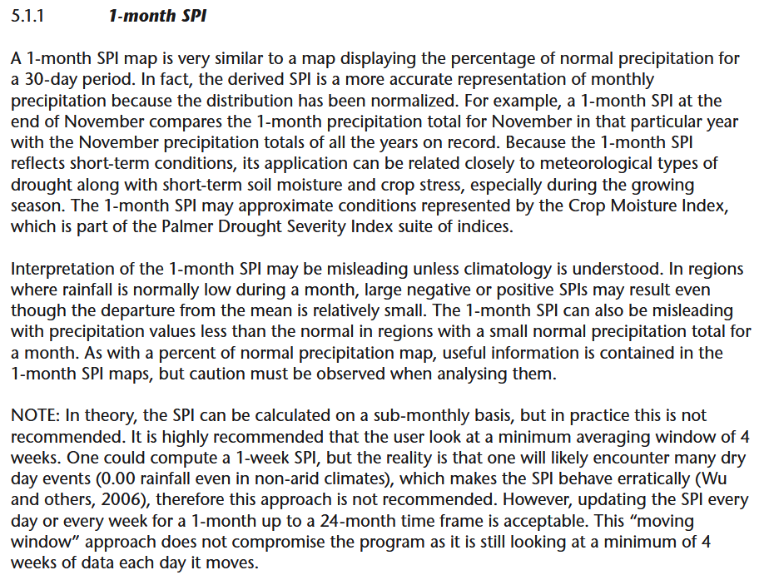
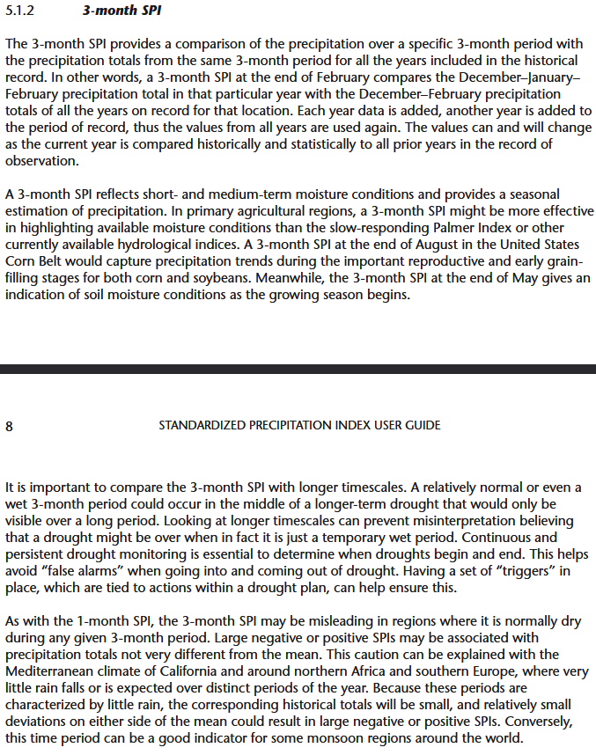
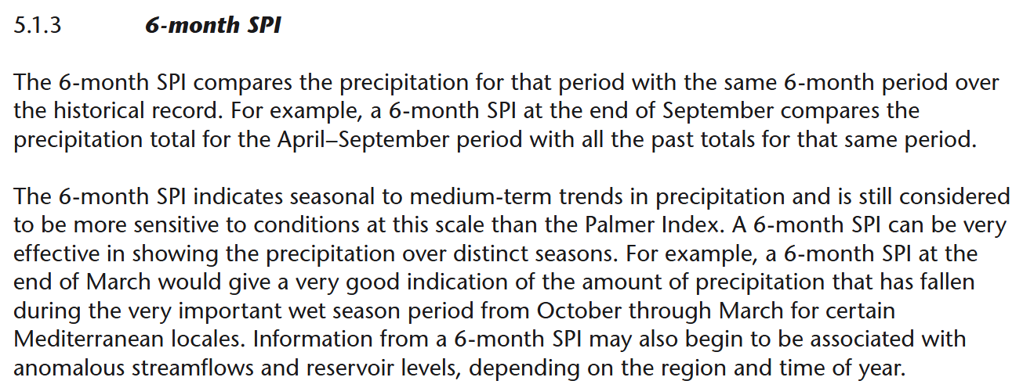
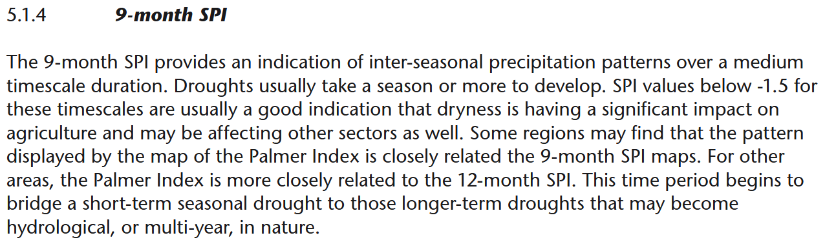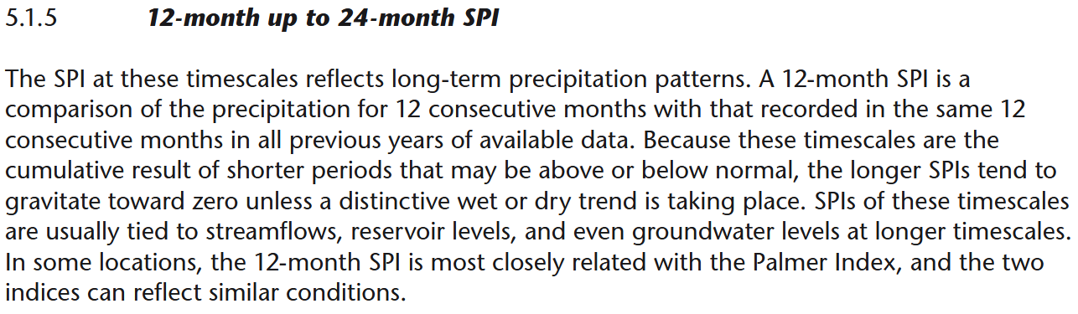
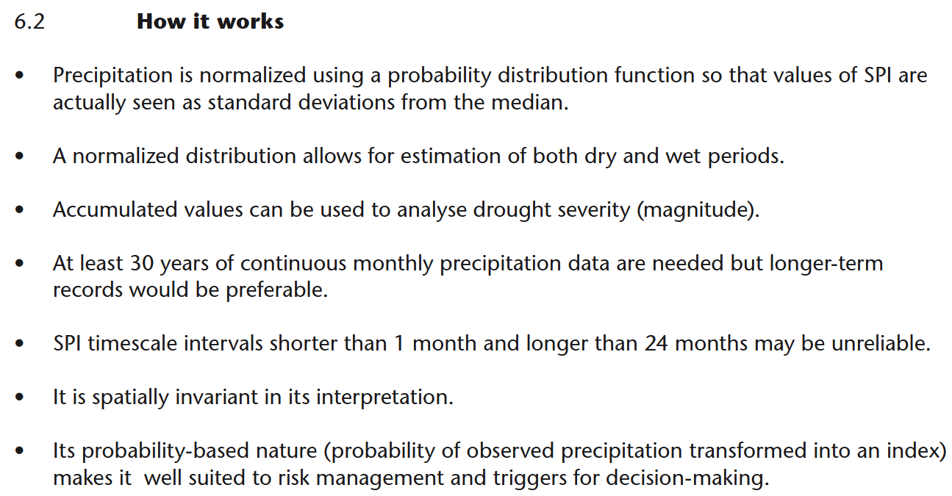
Cool Drought Tool:
https://www.drought.gov/states/missouri
Time series analysis is critical for SPI driven studies
https://www.in.gov/dnr/water/water-availability-use-rights/water-resource-updates/monthly-water-resource-summary/explanation-of-standard-precipitation-index-spi/
